**Table of contents**

1. Arriving at Halmstad Steel Service Center
2. Truck Driver Equipment
3. Document handover
4. Loading of goods
5. Unloading of goods
6. Departure from Halmstad Steel Service Center
7. **Arrival at Halmstad Steel Service Centre (HSSC)**

* Address: Turbingatan 1, 302 50 Halmstad
* Loading takes place 05:30–18:00
* If the gate/gate is closed, call 0709 83 30 71 or 0709 83 30 72
* Follow signs to the correct loading port
* Take note of and respect posted information and warning signs
* When queuing trucks – keep your distance from the previous truck when parking

1. 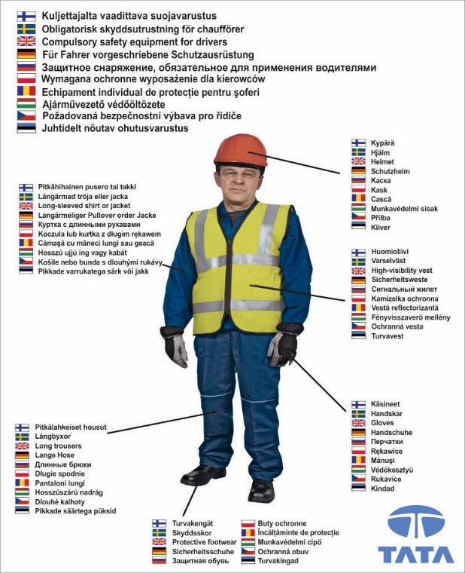**Driver´s safety equipment**The following safety equipment is mandatory for all drivers as long as they are on the HSSC grounds.
2. **Shipping Document Handover**

- Keep the speed limit – max 20 kilometers/hour throughout the area  
- When unloading the coil: drive to port E  
- When unloading format sheet: drive to port A  
- When picking up goods: contact warehouse staff at gate C for further instructions  
- Contact the forklift driver and hand over the shipment number or consignment note

**A**

**C**

**B**

**E**

1. **Loading of materials**

- Listen to the forklift driver's instructions  
- Turn off the engine and remove the key from the ignition switch

- Make sure the parking brake is applied  
-Observe safety distances to forklifts  
- When interacting and engaging with forklift drivers – make sure that you are clearly visible and that the driver has seen you before you approach them  
- When the forklift driver has carried out loading, secure the load with the help of approved straps for the purpose  
-Respect that forklift drivers have a mandate to fail load securing and that you may be asked to secure the load further

1. **Unloading of materials**

- Listen to the forklift driver's instructions  
- Turn off the engine and remove the key from the ignition switch  
- Make sure the parking brake is applied

- Opening of truck gates, canopies etc is only allowed after approval by warehouse staff

- Loosen the load fuse and notify forklift drivers when unloading can begin  
- Observe safety distances to forklifts

- When unloading has been carried out, the truck may only leave the area when gates, canopies, etc. are secured for departure

- Respect that forklift drivers have a mandate to fail to secure the above

1. **Departure from Halmstad Steel Service Center**

- Receive a signed consignment note from forklift drivers

- Follow the given instructions and pay attention to posted signage

- If the barrier and/or gate is closed – ask the forklift driver to open it